# Masters Progress Report

Very High Resolution Remote Sensing of *Portulacaria Afra* Canopy Cover

Dugal Harris, Dec 2013

## Summary

The camera corrected raw imagery was successfully orthorectified. A cross calibration tool was developed and applied to the rectified imagery using MODIS NBAR data as a reference. The cross calibration procedure was shown to be sound by validating results against SPOT imagery of the study area. Classification experiments were conducted on a small subset of the calibrated imagery. Separate classifiers trained on each ground truth area produced promising classification results. Work remains to deal with the challenge of variation in vegetation colour and intensity over the study area.

## Rectification and Cross Calibration

Following correction of the raw imagery for camera radiometric and geometric effects, the processed raw imagery was successfully rectified using the aero-triangulation information from NGI. A mosaic of the rectified imagery is shown bordered by the green box in Figure 1. Colour and intensity variations are clearly apparent in this mosaic. These are due to exposure and BRDF effects as discussed in the previous report.

Rather than attempt a complete radiometric calibration from scratch, the effectiveness of a cross calibration approach was investigated. Cross calibration has the advantages of being relatively simple, time efficient and not requiring any absolute spectral references on the ground. A well calibrated image from another source is used as a reference to which the aerial imagery is calibrated. The spatial resolution of the reference image is usually much coarser than the aerial imagery. MODIS NBAR data was chosen as a reference source as it is freely available, has been processed with an established and verified BRDF calibration procedure and has similar spectral bands to the NGI imagery. A spatially varying, linear adjustment was made to the NGI imagery using this approach. Figure 2 shows the cross calibrated mosaic (inside the green border) against a backdrop of the MODIS reference image. The variations apparent in Figure 1 have been smoothed out and there is a good match between the corrected mosaic and MODIS reference.

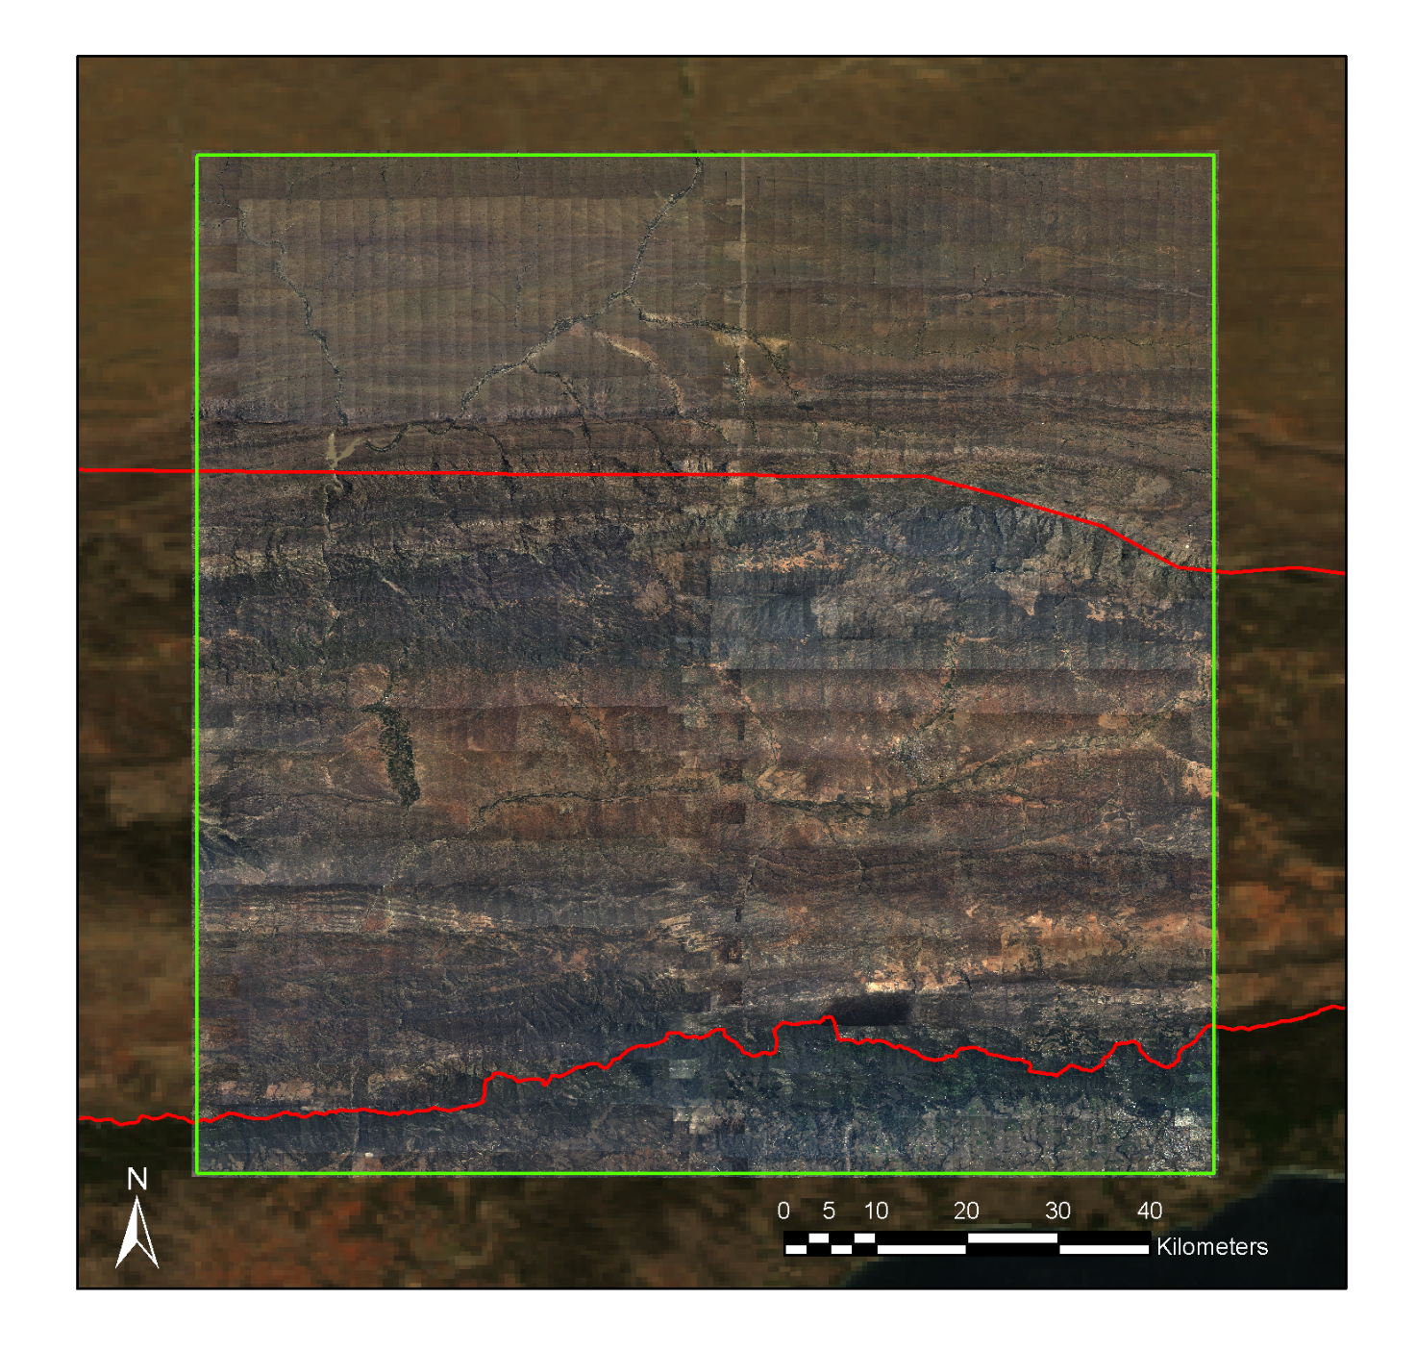

Figure : Mosaic of Rectified NGI Imagery

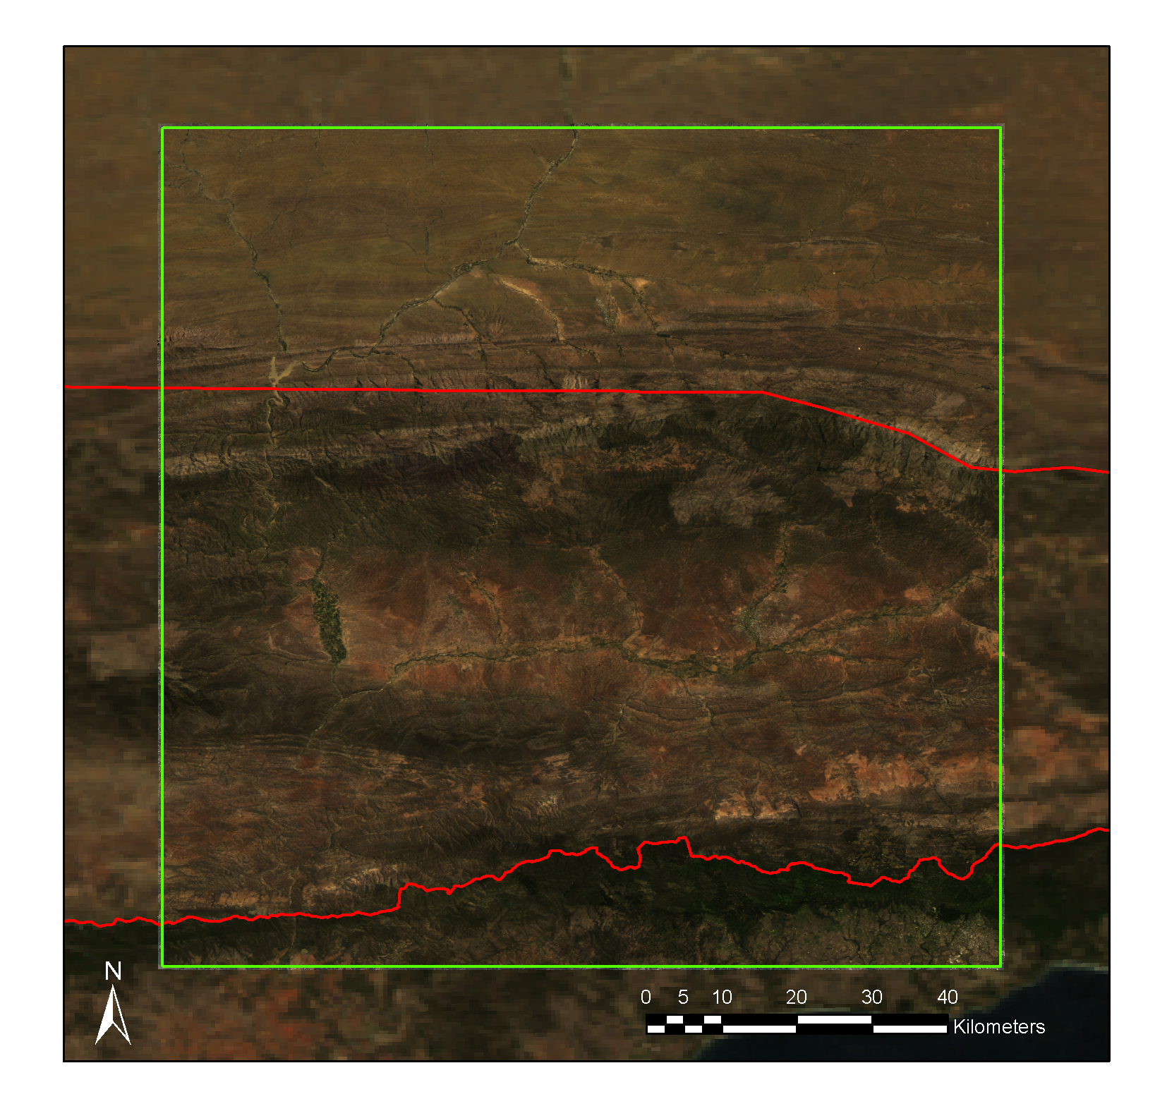

Figure : Mosaic of Cross Calibrated NGI Imagery

While the cross calibration results are visually compelling, it is possible that these adjustments have damaged spectral information at a fine spatial scale. In order to quantify the accuracy of the cross calibration at a fine spatial scale, the results were compared to SPOT images. SPOT images of the study area at appropriate capture times were sourced from SANSA. The SPOT 5 satellite was selected as a data source as it has similar spectral bands to the NGI sensor and has a relatively high spatial resolution of 10m per multispectral pixel. The SPOT images were converted to surface reflectance values using a standard atmospheric correction algorithm. Further to this, a scene wide colour balance was applied to the SPOT imagery in order to match it with the MODIS reference. The SPOT scenes were then compared to the cross calibrated NGI imagery. Figure 3 and Figure 4 show examples of scene comparisons at differing scales. The scenes are shown in CIR format as the SPOT images lack a blue band. The error was calculated as the absolute difference between the SPOT and NGI imagery. The error images in Figure 3 and Figure 4 have been stretched significantly in order to emphasize details. While there was some concern over the accuracy of various assumptions made in the cross calibration procedure, the validation results appear remarkably good. The mean absolute error between the NGI and SPOT images was roughly 2% in reflectance units.

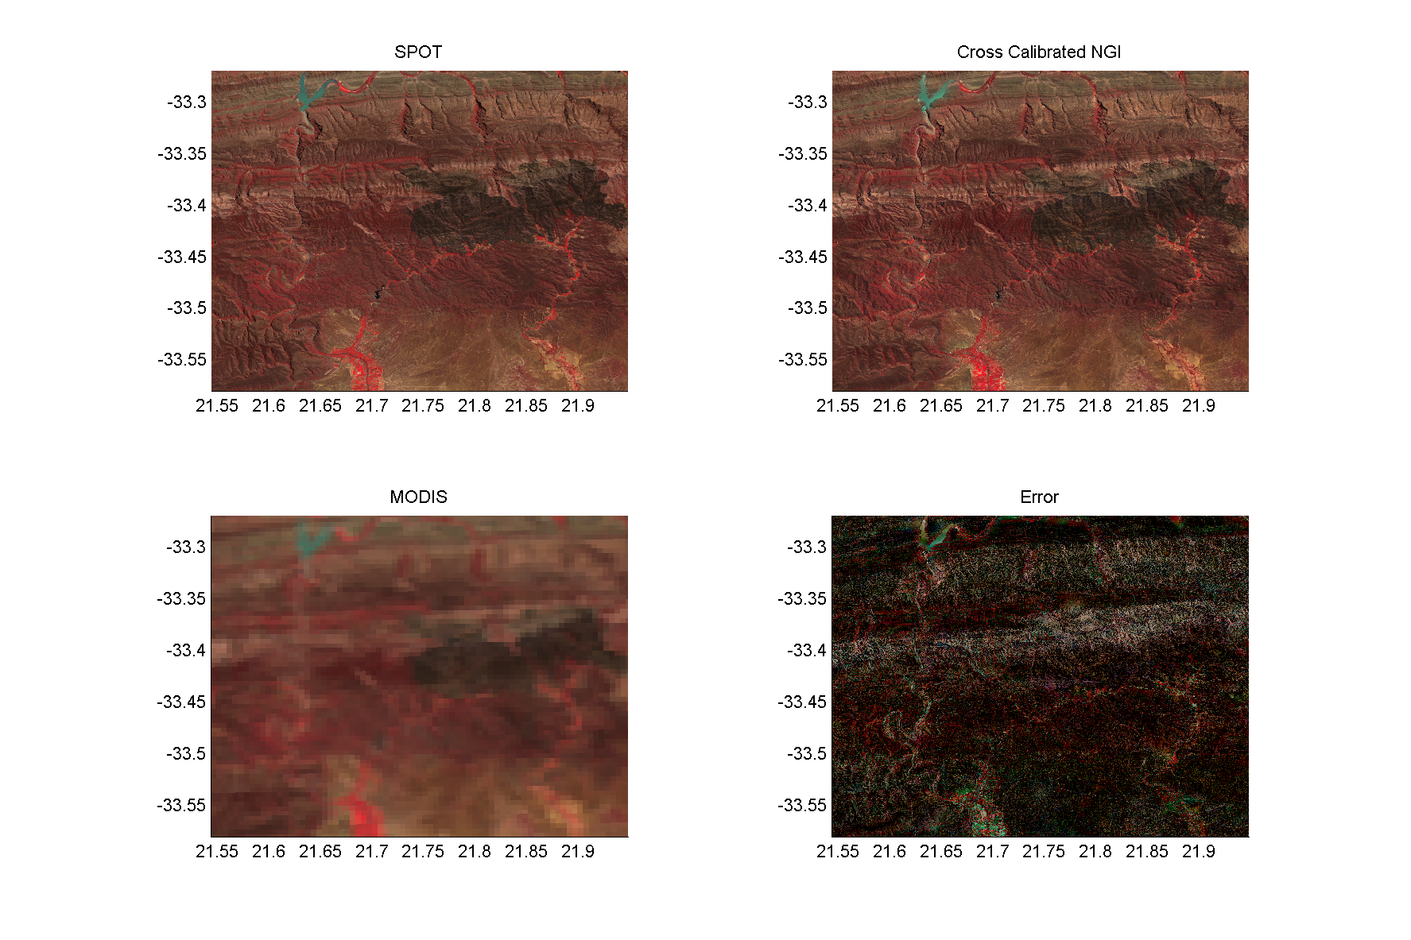

Figure : Validation of Cross Calibrated Imagery with SPOT data – Scene 1

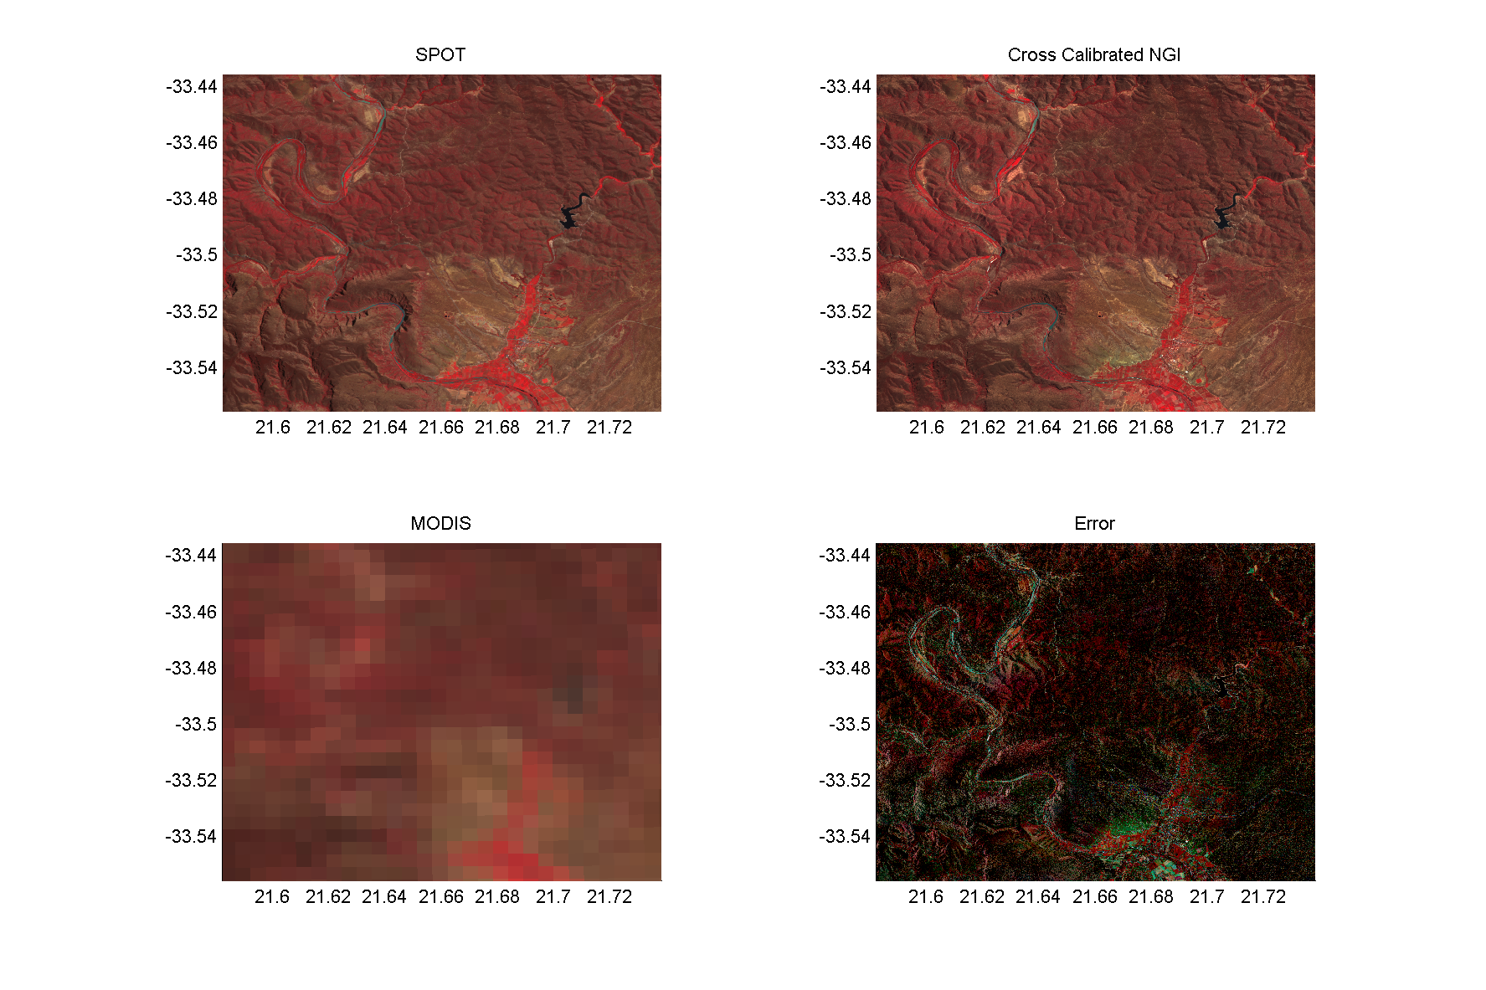

Figure : Validation of Cross Calibrated Imagery with SPOT data – Scene 2

## Classification and Canopy Cover Measurement

Classification and canopy cover measurement experiments have been conducted on the cross calibrated imagery of the study area. Four images covering the areas ground truthed at the end of 2012 were selected for the purposes of these experiments. The use of a small representative subset of the complete study area allowed different approaches to be quickly evaluated. Ground truth was generated by hand-labelling portions of each image. It was found that visually distinguishing Spekboom from background vegetation was more challenging than was the case in the initial classification study conducted in 2012. This was particularly noticeable when Spekboom occurred as isolated individual plants amongst a mosaic of similarly sized vegetation.

Common per pixel features were extracted for the labelled areas including normalised colour, NDVI and some basic texture measures. A branch and bound procedure was used to select the best features and these were subsequently used to train a simple classifier. It was found that a single classifier did not generalise well over the four scenes due to substantial variation in the colour of Spekboom and background vegetation. Given the success of the cross calibration validation, it is believed that this variation is real and not due to calibration issues. Subsequently, four separate classifiers were trained, each on one scene. All the classifiers achieved a 90% or better accuracy when tested on unseen portions of the hand labelled data. Probability maps generated by these classifiers appear reasonable and are shown in Figure 5 to Figure 8 for example scenes. Habitat types are noted in brackets in the figure captions.

The classifiers were applied to the areas ground truthed with Jan Vlok in 2012. The classifier generated canopy cover measurements were compared against the ground truth values. The mean absolute canopy cover error was 7%, measured over all twenty ground truth sites. This seems a good result, especially considering the ground truth values themselves are not accurate as they were derived in a subjective manner i.e. visual inspection. It is important to note that these results are not indicative of what would be achieved by a single classifier applied to the entire study area. As the classifiers were customised to each ground truth area, these results probably represent a best case scenario of what a single classifier would produce over the whole study area. Nevertheless, it seems the potential for a useful solution is there.

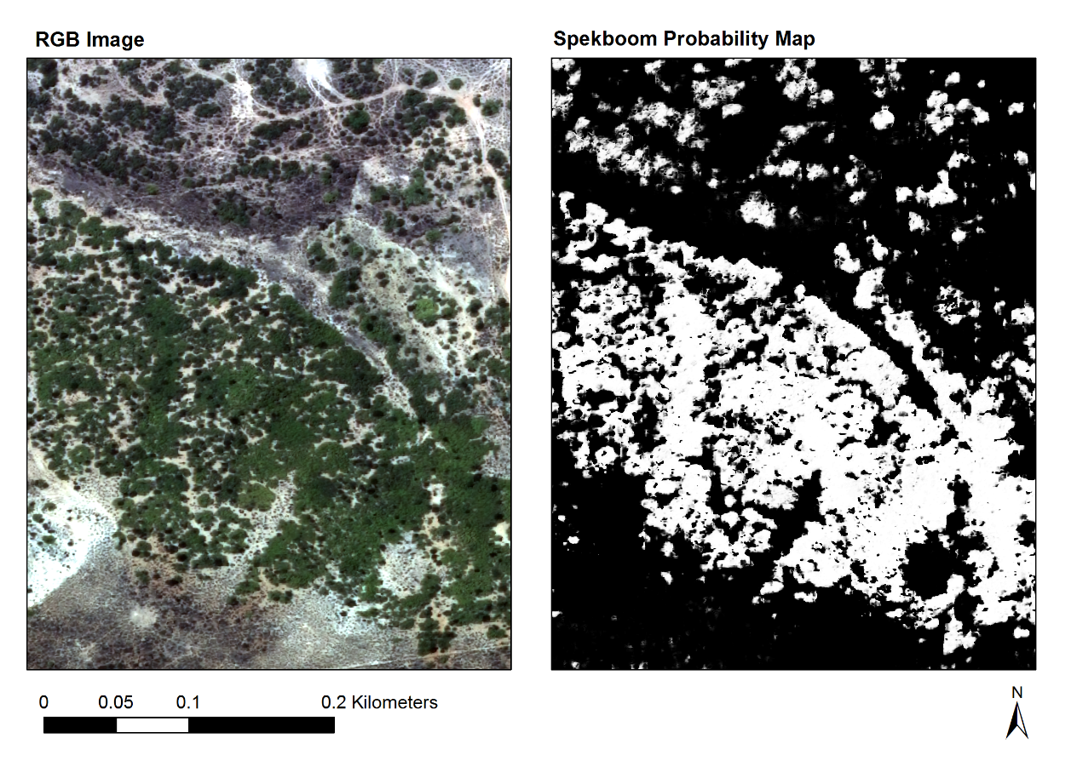

Figure : Grootkop Classification (Arid Thicket with Spekboom and Succulent Karoo Mosaic)

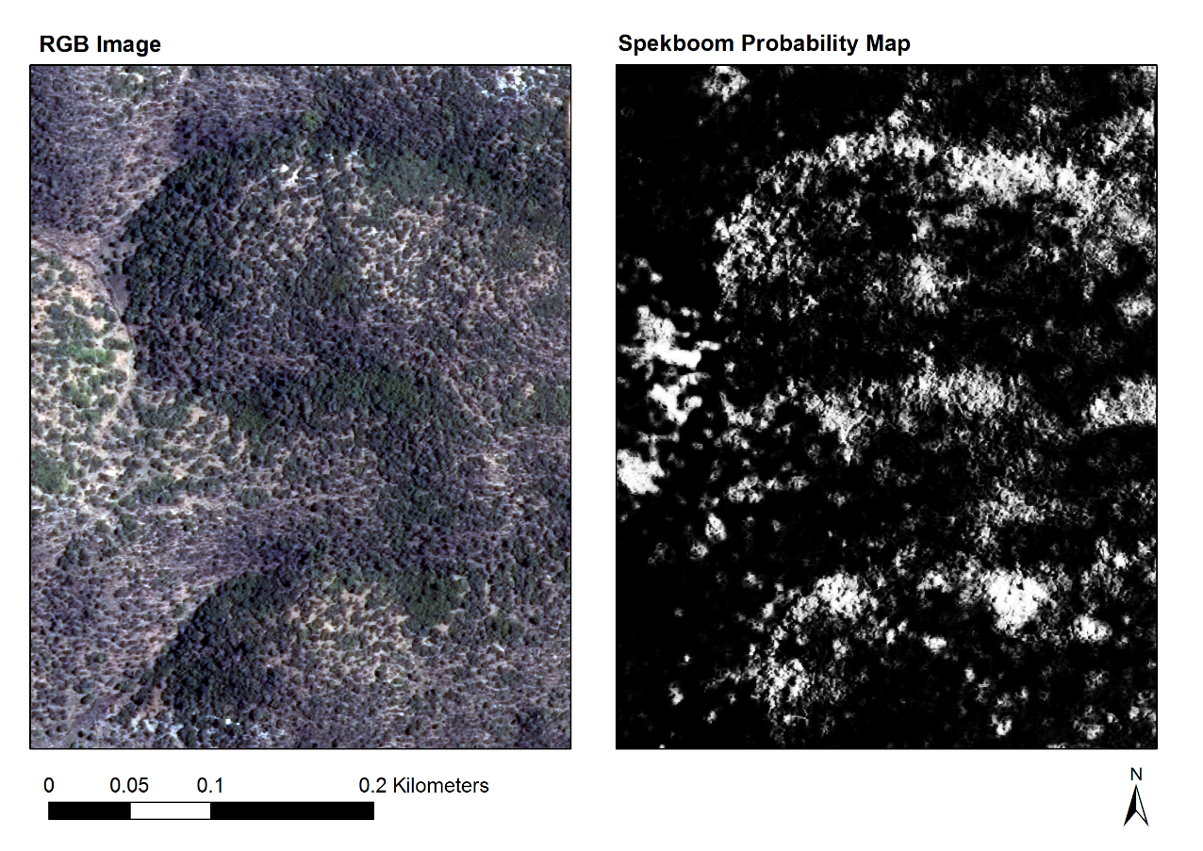

Figure : Groenfontein Classification (Valley Thicket with Spekboom)

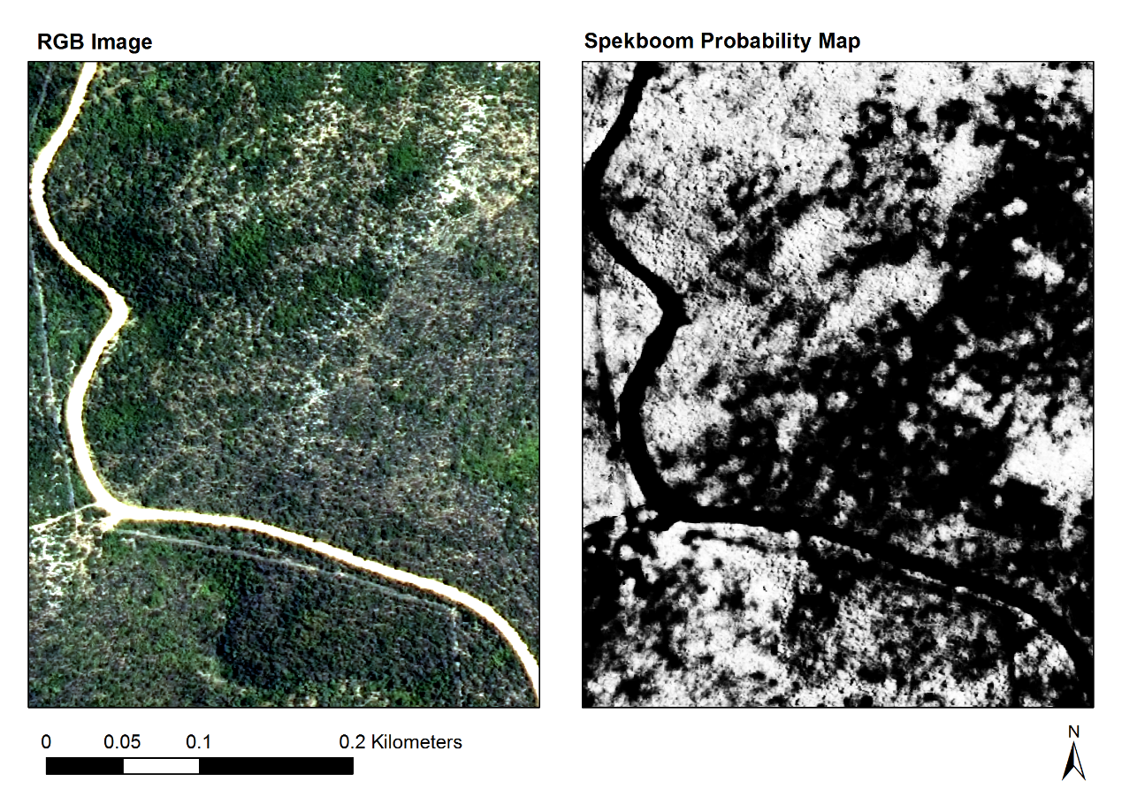

Figure : Matjiesvlei Classification (Arid Thicket with Spekboom)

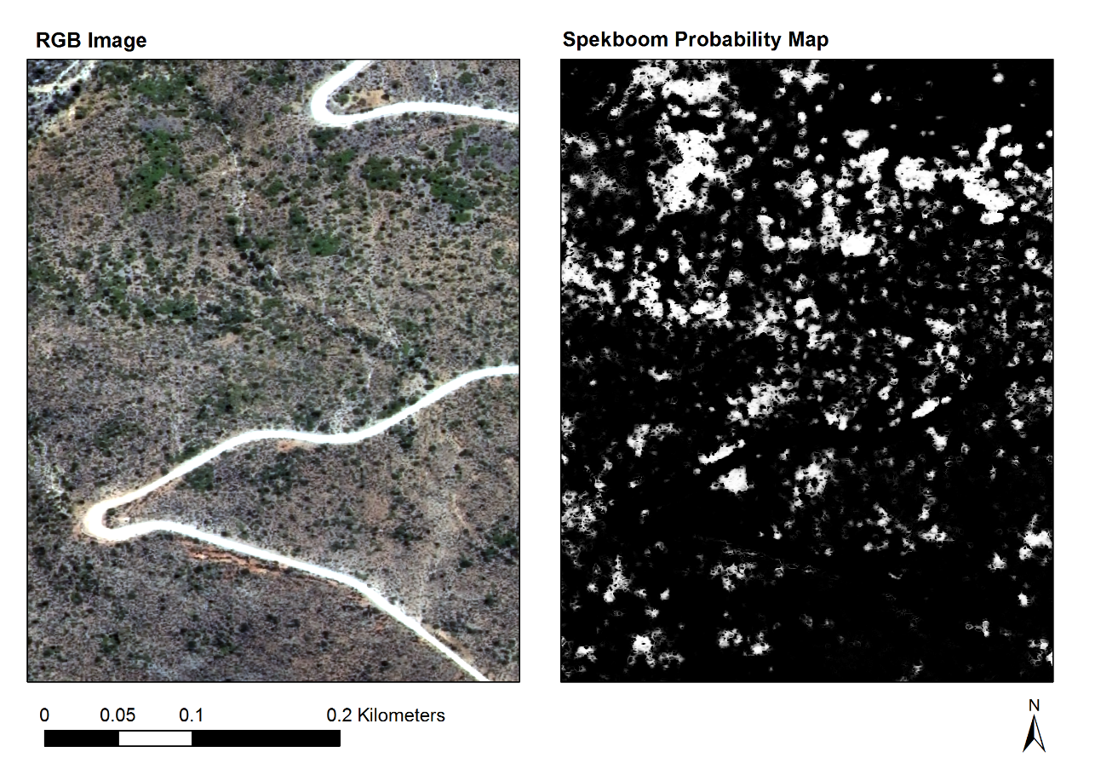

Figure : Rooiberg Classification (Arid Thicket with Spekboom and Fynbos Mosaic)

## Future Direction

Further classification work will be conducted to investigate if it is possible to create a structured approach to classification that will be capable of generalising over the variation encompassed in the study area. The potential for the application of habitat specific classifiers will be investigated. A final classification algorithm will be applied to the study area and used to generate a canopy cover map. Results will be validated against existing ground truth and in the field, in collaboration with Jan Vlok.